Test Case: runTestMultipleTimes
Step 1 - Enter username and password and click to button Enter : Credentials Entered
Image file-name: QC_Testing-runTestMultipleTimes-dic. 03 2025, 09 27 21 a. m.

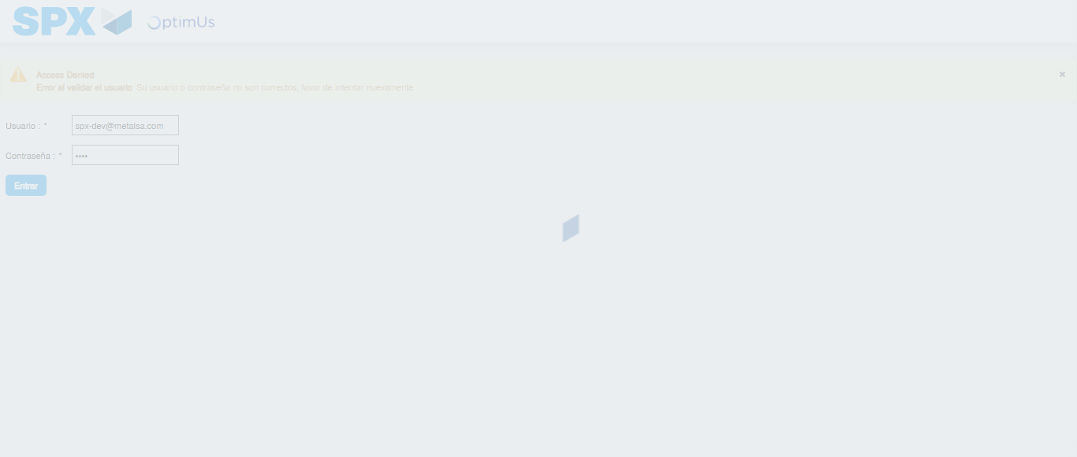Image file-name: QC_Testing-runTestMultipleTimes-dic. 03 2025, 09 27 22 a. m.

Step 2 - Select to UEN and Access to Administrador Roles Menu: UEN Correctly selected and Correct access
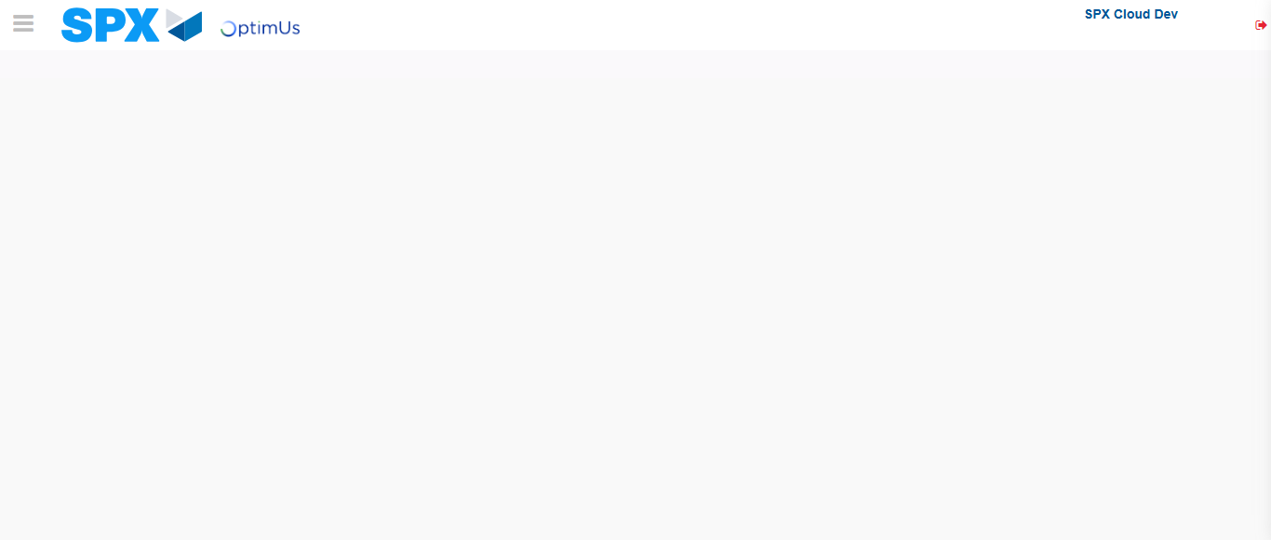Image file-name: QC_Testing-runTestMultipleTimes-dic. 03 2025, 09 27 30 a. m.

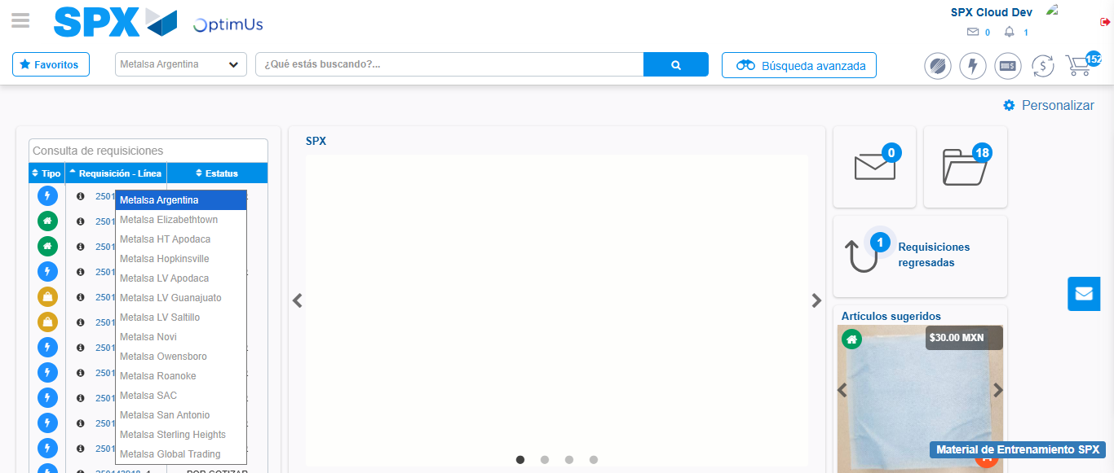Image file-name: QC_Testing-runTestMultipleTimes-dic. 03 2025, 09 27 31 a. m.

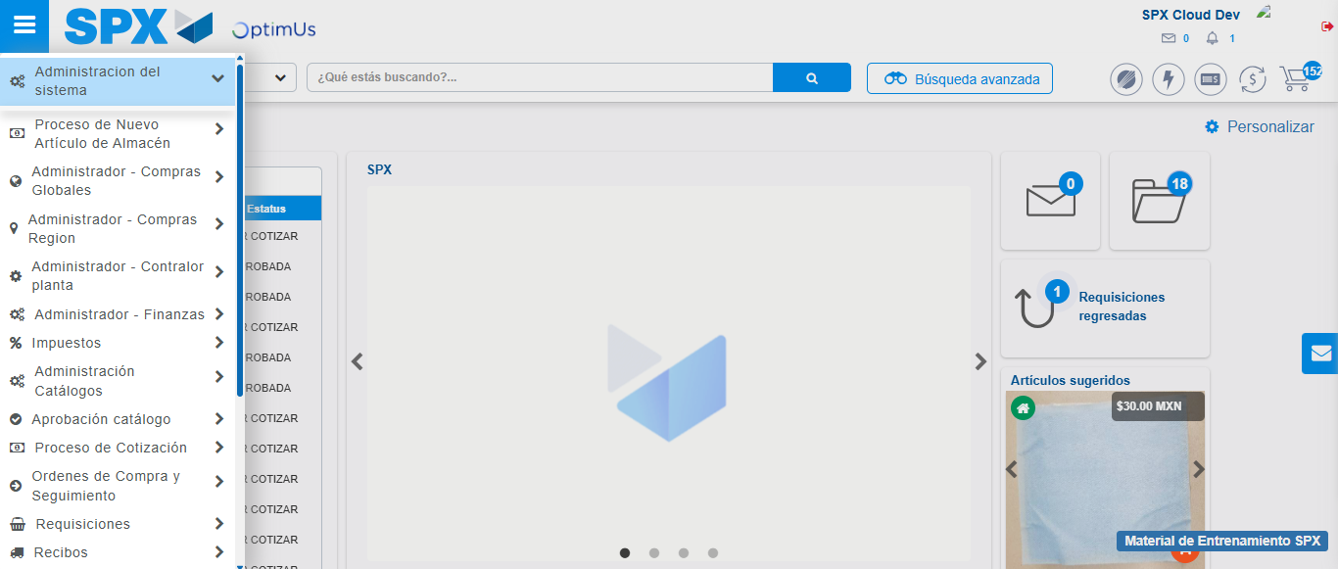Image file-name: QC_Testing-runTestMultipleTimes-dic. 03 2025, 09 27 32 a. m.

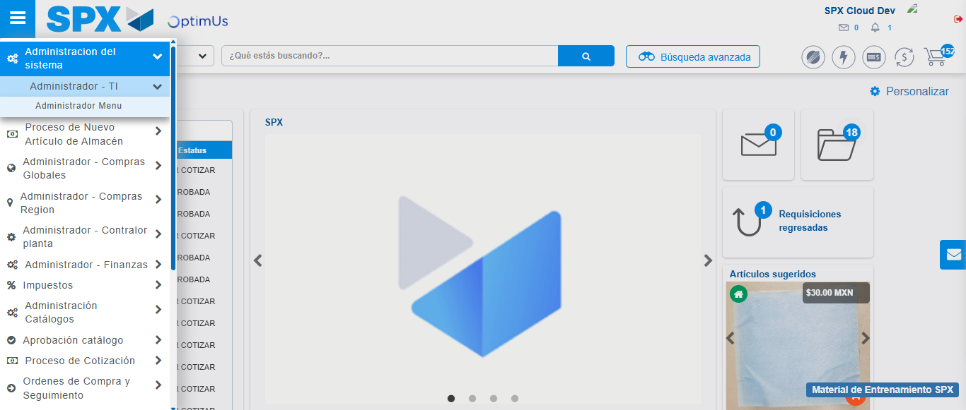Image file-name: QC_Testing-runTestMultipleTimes-dic. 03 2025, 09 27 33 a. m.

Image file-name: QC_Testing-runTestMultipleTimes-dic. 03 2025, 09 27 34 a. m.

Step 3 - Click to Buttons View Menu and Search Filter with Menu Name and Add new record and Delete Record: Correct Search and Record successfully added and Record successfully deleted
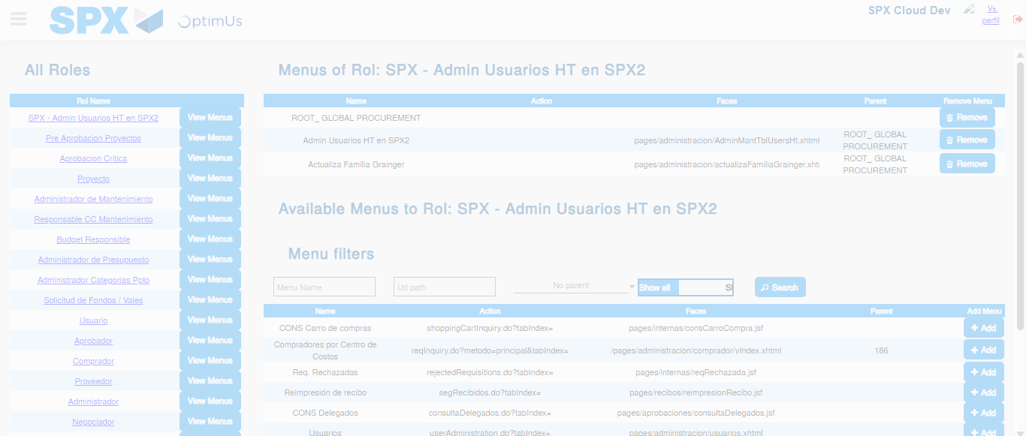Image file-name: QC_Testing-runTestMultipleTimes-dic. 03 2025, 09 27 35 a. m.

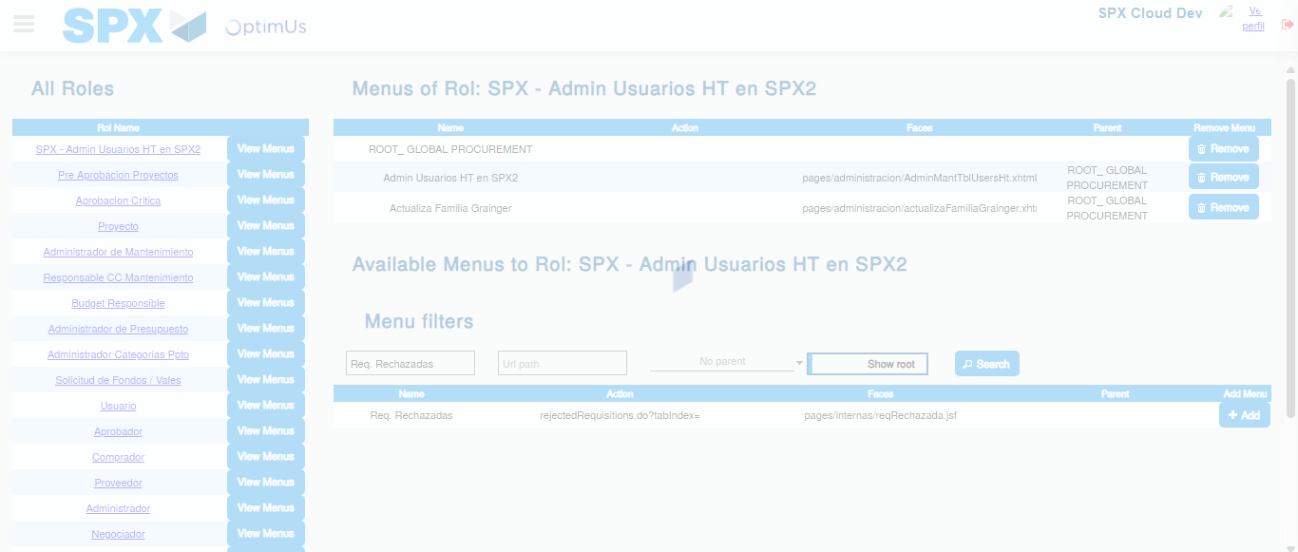Image file-name: QC_Testing-runTestMultipleTimes-dic. 03 2025, 09 27 36 a. m.

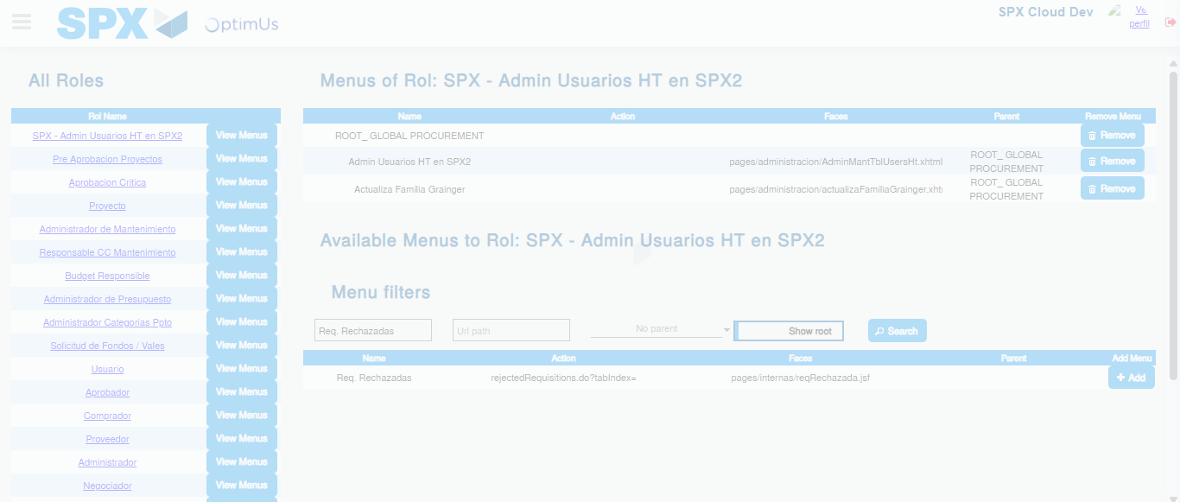Image file-name: QC_Testing-runTestMultipleTimes-dic. 03 2025, 09 27 37 a. m.

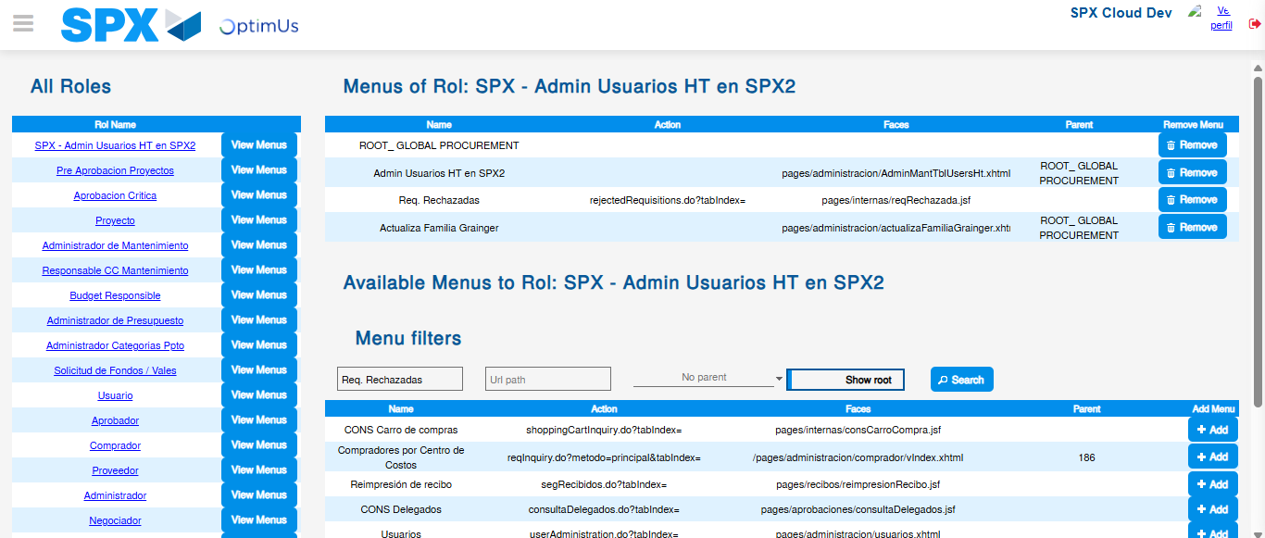Image file-name: QC_Testing-runTestMultipleTimes-dic. 03 2025, 09 27 40 a. m.

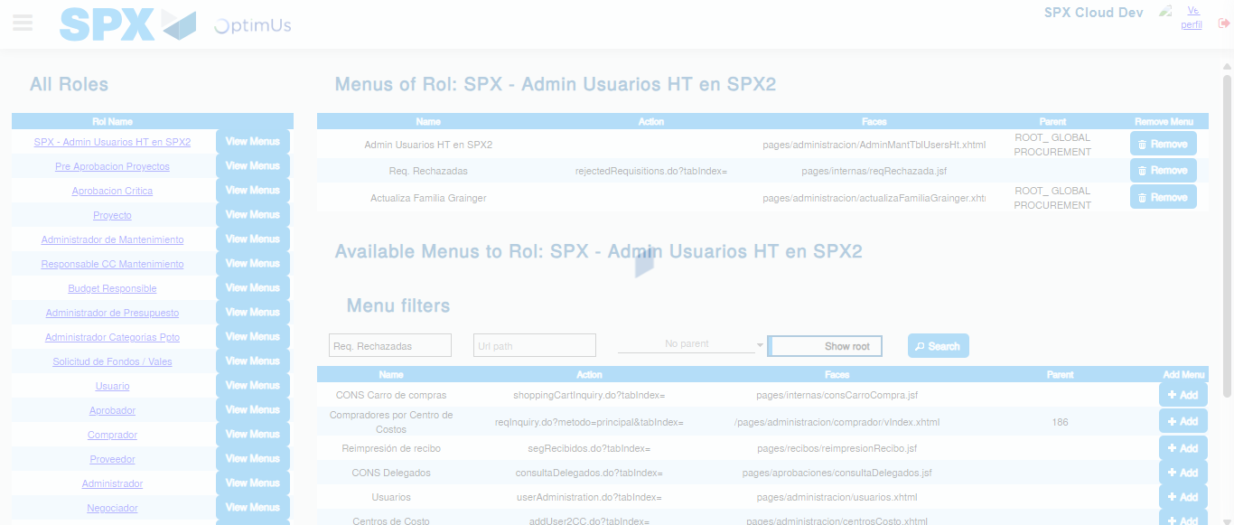Image file-name: QC_Testing-runTestMultipleTimes-dic. 03 2025, 09 27 41 a. m.

